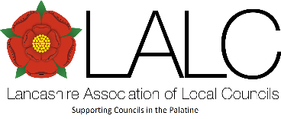

Agenda – Fylde Area Committee Meeting – Thursday 4th December 2025: 6.30pm

Venue – ‘Kirkham Community Centre’, Mill Street, Kirkham, PR4 2AN.

Agenda items Lead

- Welcome and Apologies Chair

- Matters arising from previous minutes (22-05-25 meeting) Chair

- Local Government Reorganisation (LGR): update Allan Oldfield

- Fylde District Parish Liaison meeting: update Chair

- LCC – Communities Team: Info Sharing and Support offer Laura Worden

- FCMS – Health Checks offer Nikki Bowden

- Fylde Energy Working Group (EWG): update Cllr. Smith

- Topics for the Fylde AC group to consider creating ‘Working Groups’ for and which the group would also like the LALC Executive Committee to further support (e.g. LGR related / Highways issues) Chair / All

- Future Agenda items All

- Date of next meeting (to be confirmed) Secretary

